**User Guide**

**Data Dissemination**



USER GUIDE – DATA DISSEMINATION

*Modern Statistics Platform*

**Revision History**

|  |  |  |  |
| --- | --- | --- | --- |
| Name | Date | Reasons of Changes | Version |
| iTM | 08th December 2023 | The first draft of data dissemination MauStats. | V1 |
| iTM | 19th June 2024 | The second draft of data dissemination MauStats. | V2 |

Table of Contents

1.0 INTRODUCTION 4

2.0 DATA DISSEMINATION 5

2.1 VISUALIZATION 6

2.1.1 DATA 7

2.1.2 SET DATA 9

2.1.3 SETTINGS 11

2.2 GALLERY 12

2.3 DASHBOARD 14

# 1.0 INTRODUCTION

The Modern Statistics (MauStats) Platform is developed as a web-based platform with central database to ensure consistency, security and accessibility. The platform is used to will help to automate and integrate data lifecycle from acquisition to dissemination using Generic Statistical Business Process Model (GSBPM) framework. The platform complies to manage data requirements for Census, SEE, and SBR processed data in this phase. It is also feasible for data integration based on SM requirements. This web-based platform consists of the two applications – User Interface and Data Management System (DMS).

In this user guide, we will be learning on how to use the Data dissemination module of the DMS application.

# 2.0 DATA DISSEMINATION

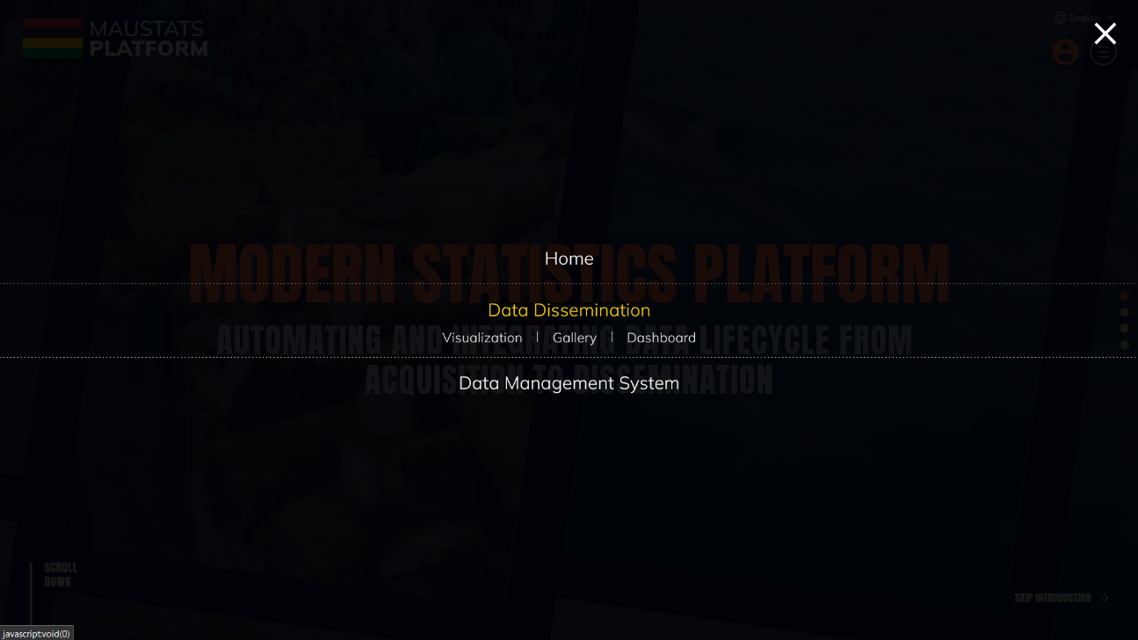The Data Dissemination module is used to access the published primary dataset and create a graphical visualization, add it in a gallery and then to create a dashboard using it. Let us learn how to use this module in detail.

## 2.1 VISUALIZATION

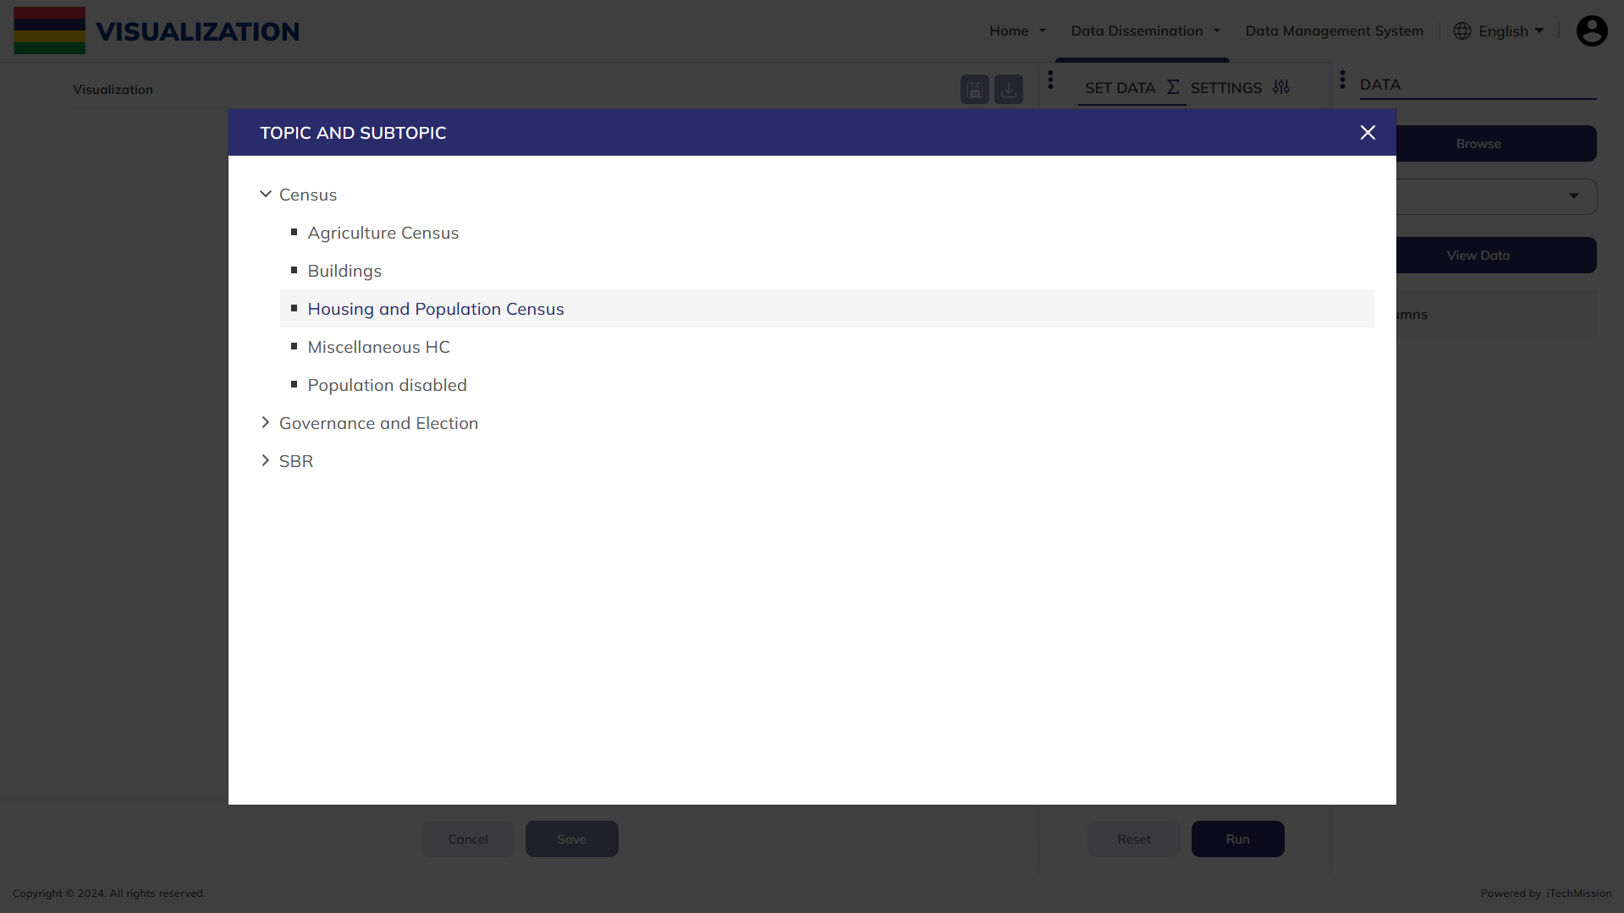This module helps to create a visualization according to the data values provided. When you navigate to visualization module, a popup window will be displayed with the list of topic and its associated subtopics. Select the relevant topic and subtopic from already published dataset on which visualization is required.

**NOTE:**

If the topic or subtopic topic is not present in the list, then first create it using topic and subtopic sub-module of data management and then ingest data using primary data sub-module of data management and them mark it as complete.

### 2.1.1 DATA

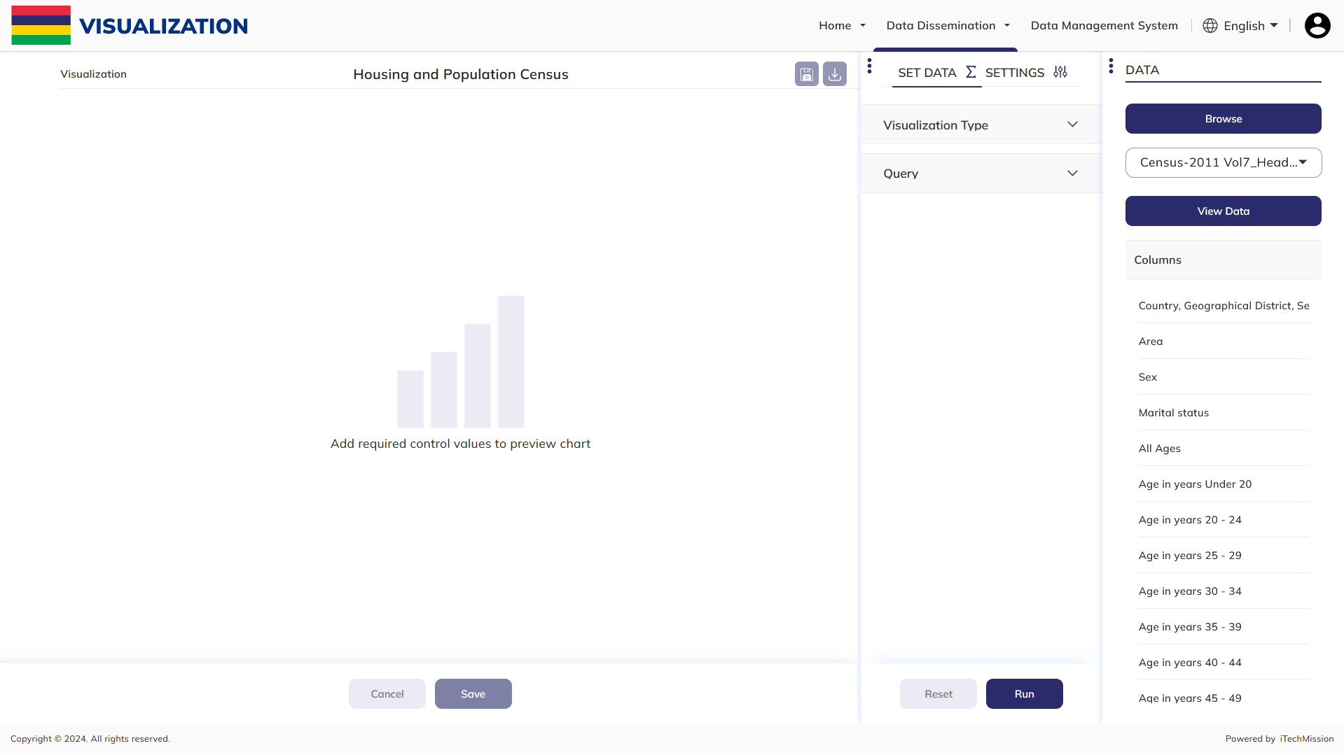**Step 1:** You can also browse the Topic and subtopic whose data is required.

**Step 2:** Click on the **Dropdown** menu to select the file which contains the data. Selected file is shown along with the column in that relevant data file.

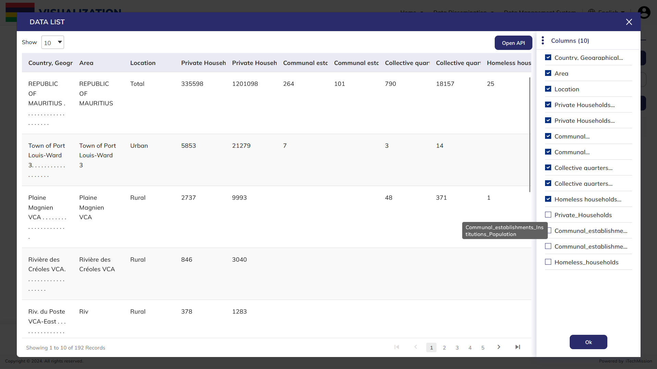**Step 3:** Click on the **View Data** to view the data of the file in tabular form.

**Step 4:** Select the columns whose data you want to view in the tabular form.

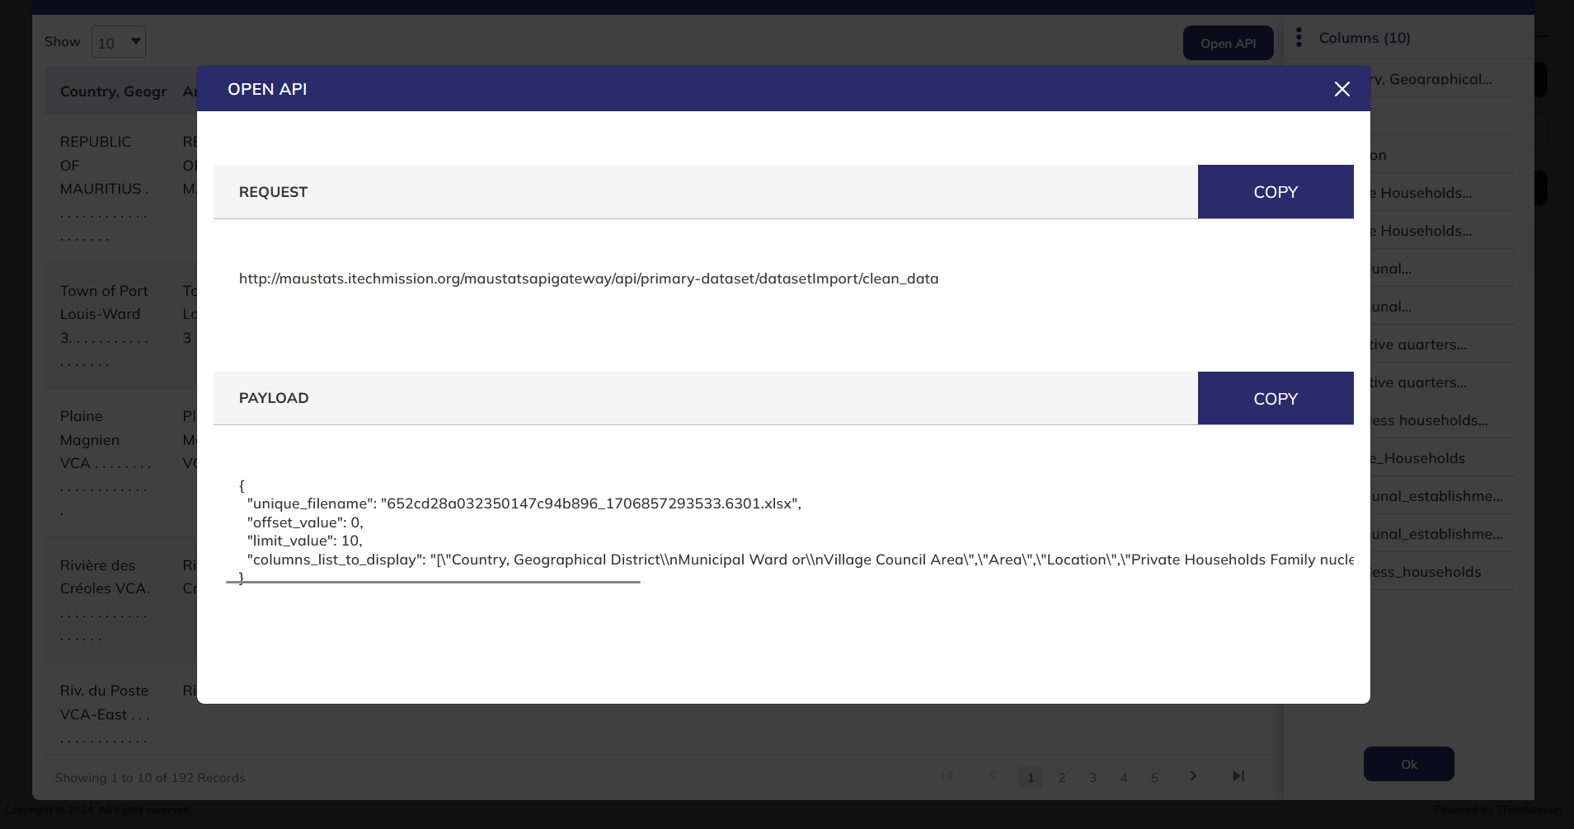**Step 5:** Click on **Open API** to get request and payload API.

**Step 6:** **Request** and **Payload** API of the selected data file

### 2.1.2 SET DATA

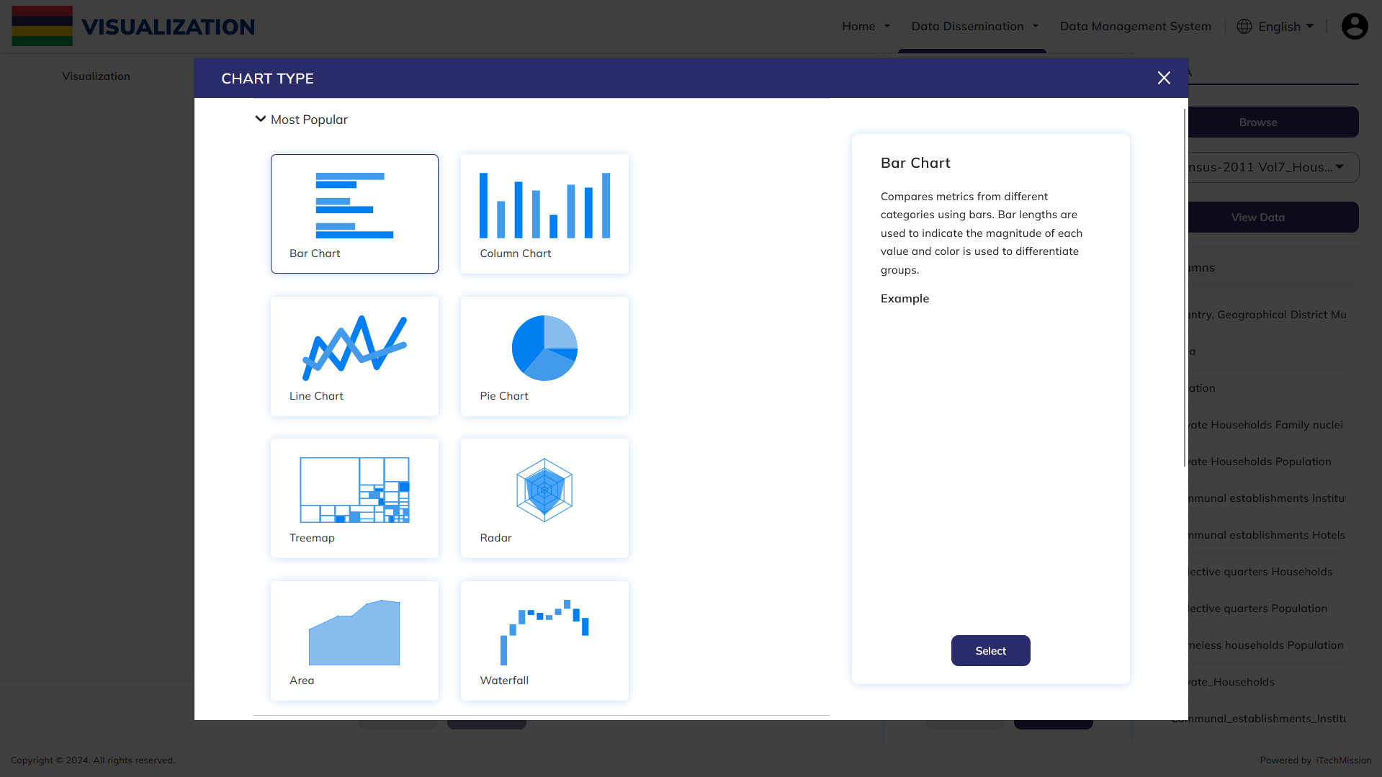**Step 7:** Select the visualization type (chart which is more preferable according to the data).

**Step 8:** In the query widget, add relevant query for visualization.

1. **Data Value –**Click on the **Column**, **Aggregate** and **Legend Value** dropdown to select data value to create visualization. In case you want to show data for multiple columns follow the same step to add more columns
2. **Filters –** Click on **Column**, **Operator** dropdown and enter the **Filter Value**. Incase if you want to add any **Filters** to the data
3. **Series -** Select Series of the data
4. **Limit** – It is the number of data that has to be shown in the graph.
5. **Offset** – It is used to resize the range of the graph source data to include an appropriate series of values.

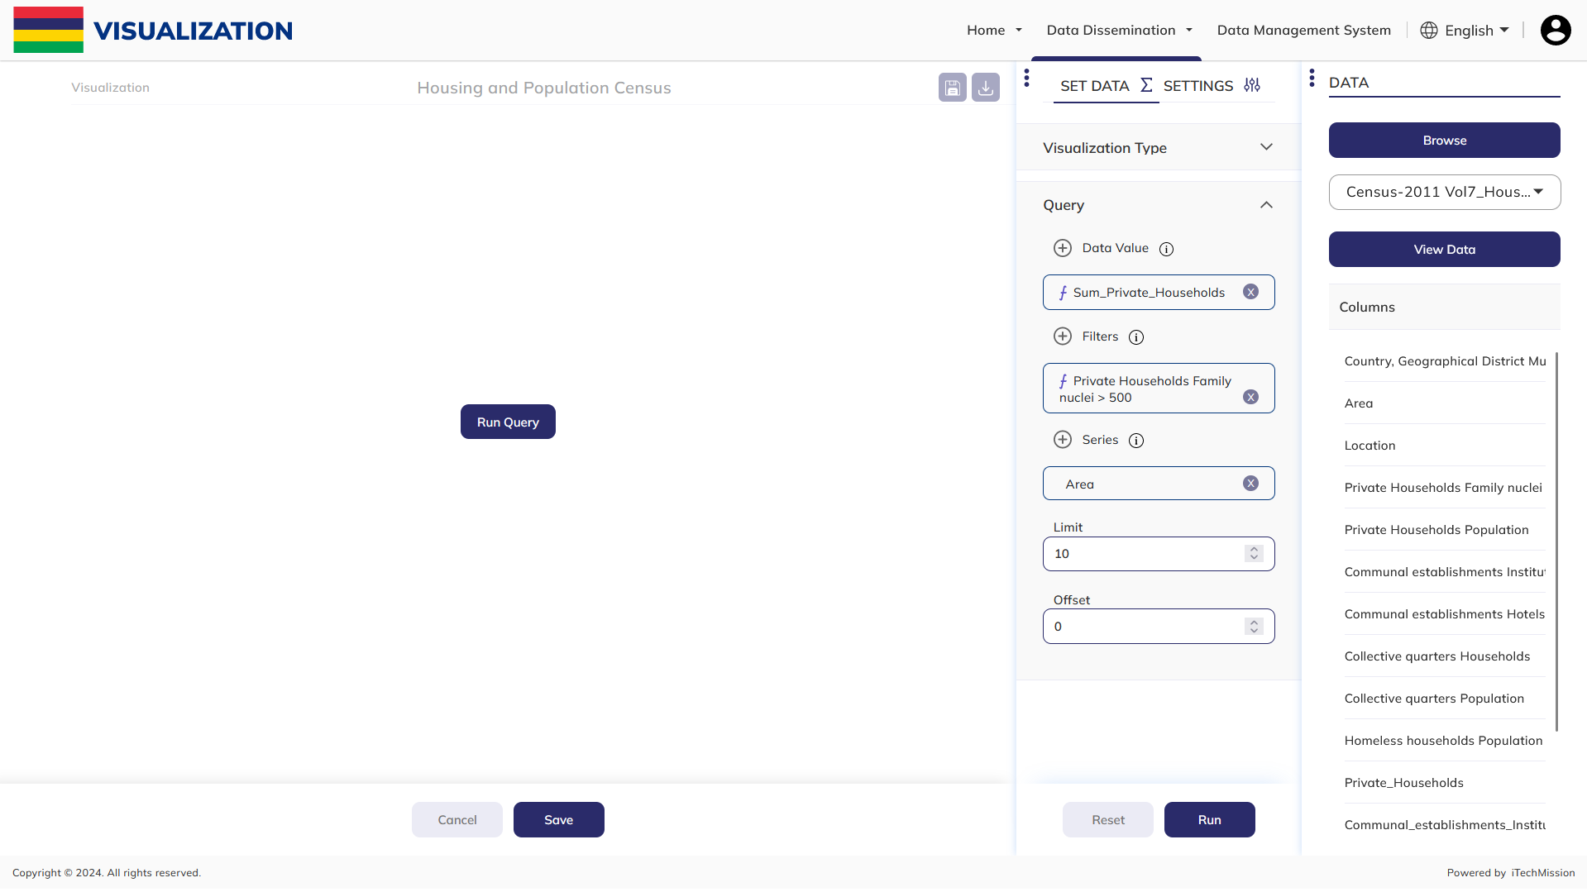

### 2.1.3 SETTINGS

**Step 9:** Click on Settings to format the graph.

1. **Title –** This is used for providing a title and subtitle to the graph. One can change the color, font, font style and size of the title and subtitle in this menu.
2. **Options –** It is used for changing label position, legend position, their color and grid of the graph. Sorting of data can also be done using this.
3. **X-axis –** This is used for providing label to the X-axis data. One can change the color, font, font style and size of the label in this menu.
4. 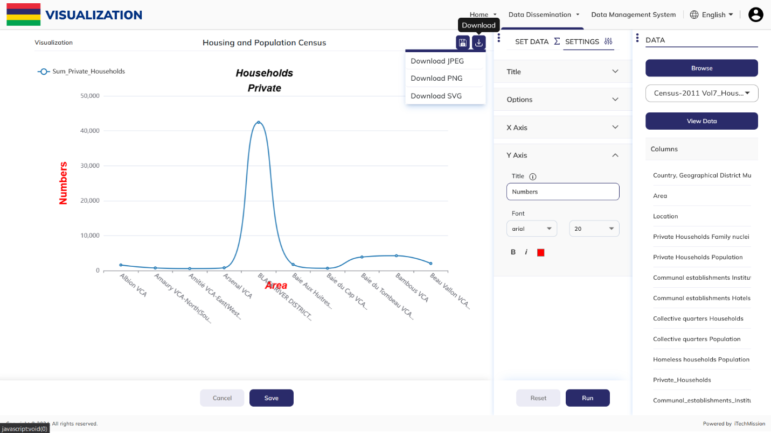**Y-axis –** This is used for providing label to the Y-axis data. One can change the color, font, font style and size of the label in this menu.

**Step 10: Run** the query.

**Step 11: Download** the visualization in the format required out of the three options.

**Step 12:** Click on **Save** to save the visualization.

## 2.2 GALLERY

A module for gallery has been created and integrated into the DMS application of the MauStats platform. This module saves the visualizations that are created from visualization module and then these save images can be used in dashboard.

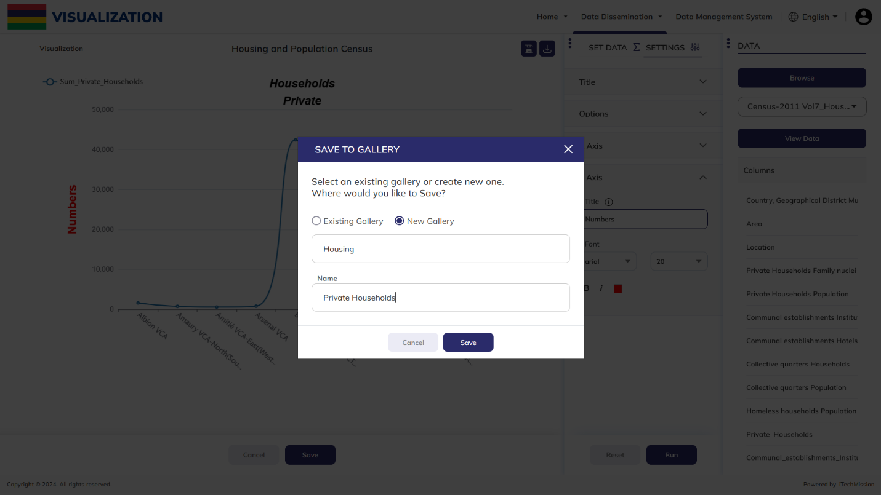**Step 1**: After clicking on **Save** button in visualization module, save to Gallery pop up appears. **Enter** the name. Click on Save button to save the image in either existing (if you want to save the visualization in a folder which is already present) or new gallery.

****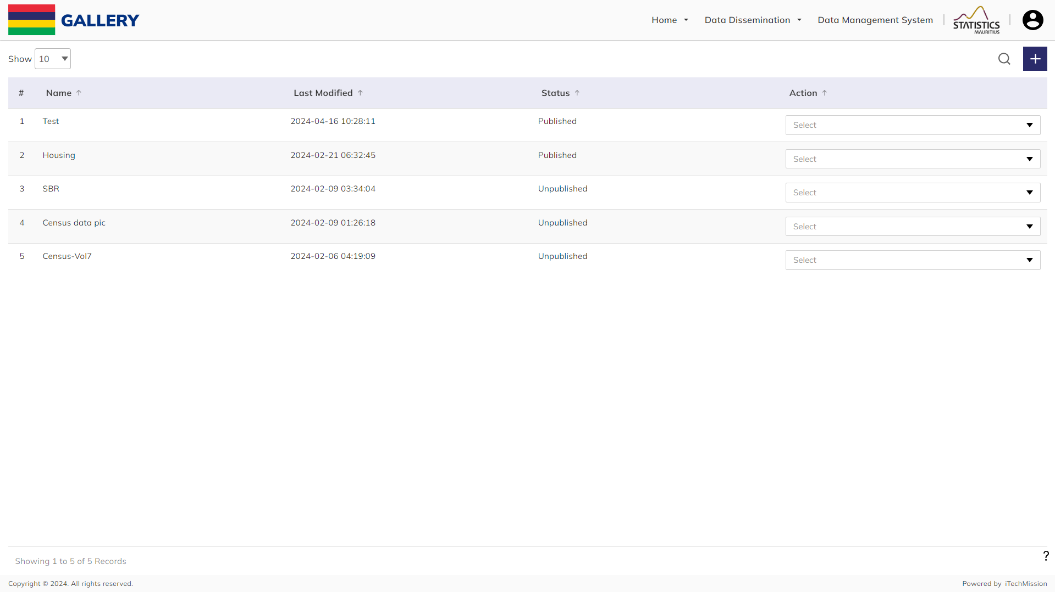**Step 2**: You can also Click on the **Plus** button to create a new visualization.

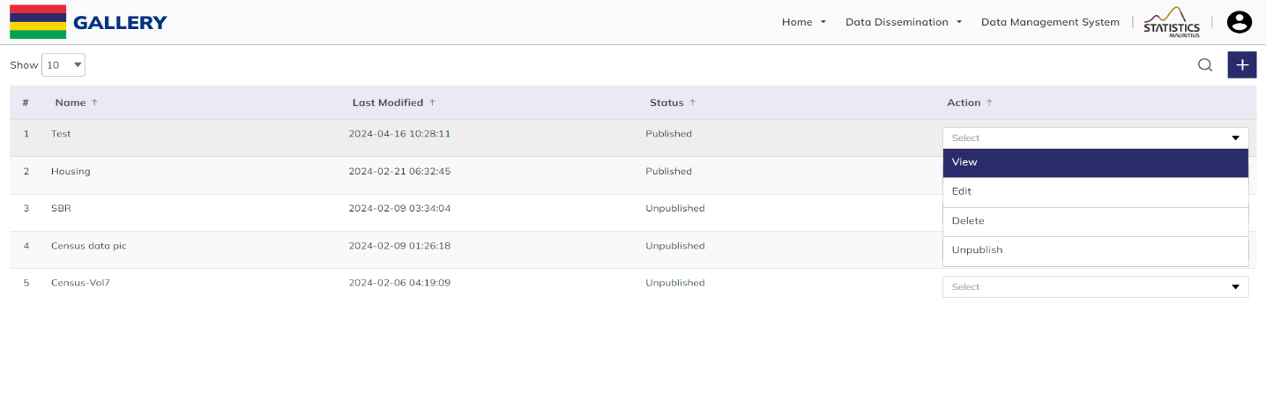**Step 3:** Click on **View** to check the folder.

**NOTE:**

New Visualization will direct you to visualization module and the topic and subtopic pop up will appear. Now you can create a new visualization.

**Step 4:** After clicking on View, particular gallery folder opens up. **Select** the image that you want to **view** in that folder

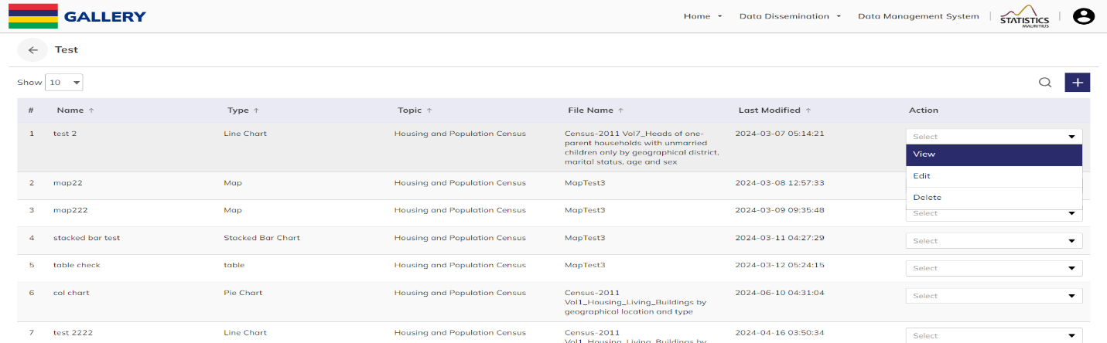**Step 5:** Click on the dropdown to **View**, **Edit**, and **Delete** the image in the folder.

**Step 6:** Click to select **Edit** option available in the action dropdown of the folder to edit the name of the selected folder. Click on Save Icon to save and confirm.

**Step 7:** Click to select **Delete** option available in the action dropdown of the folder to delete the selected folder. A confirmation popup will appear, click yes to confirm deletion of selected element.

**Step 8:** Click on **Publish/Unpublish** available in the action dropdown of the folder to publish/unpublish the folder and the images in that folder.

## 2.3 DASHBOARD

The Dashboard module allows display of your data using relevant and intuitive visualizations with primary intention to provide information at-a-glance. In this module, you will have the options to create your own dashboard, add multiple sections in a dashboard and group these sections to have an organized dashboard, publish a dashboard, edit an existing dashboard, explore the published dashboard.

****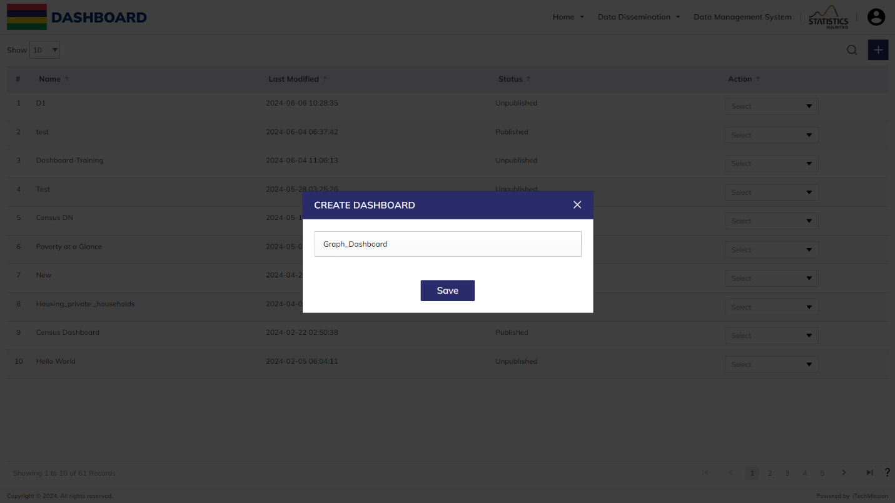**Step 1:** Click on the **Plus** button available to the top right side in the header section to add a new dashboard. Enter the name of the dashboard and click on Save button to confirm save new dashboard. A new empty dashboard will be created with options to customize your dashboard.

**Step 2:** Click on the dropdown to **View**, **Edit**, **Edit Name** and **Delete** the dashboard.

**Step 3:** After clicking on **Edit 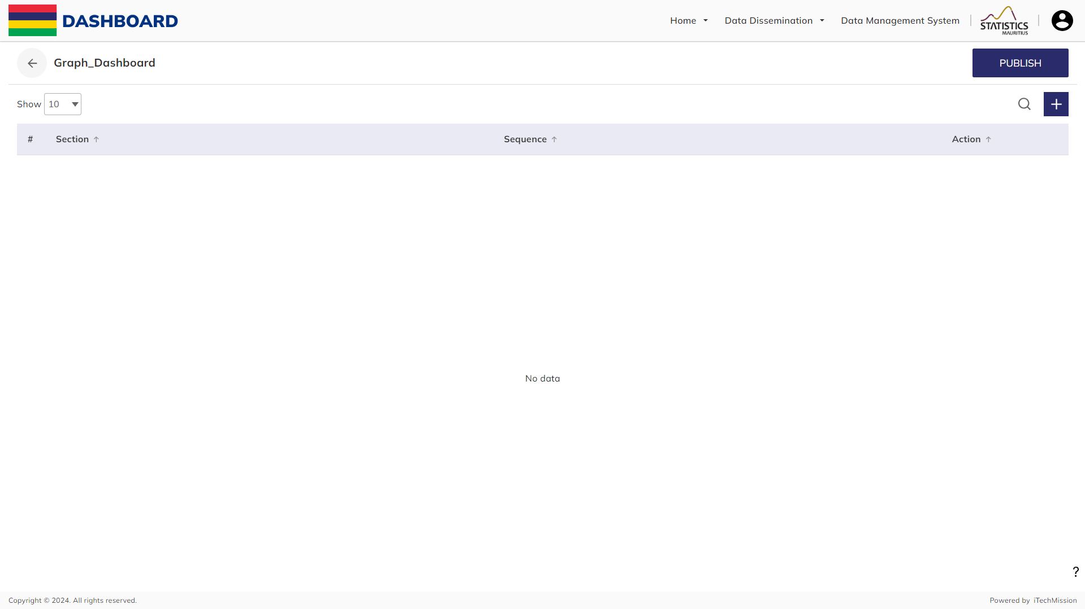**this screen appears. Now Click on **Plus** button and add multiple sections to a particular dashboard. Enter the name of the section and click on Save button to confirm new section.

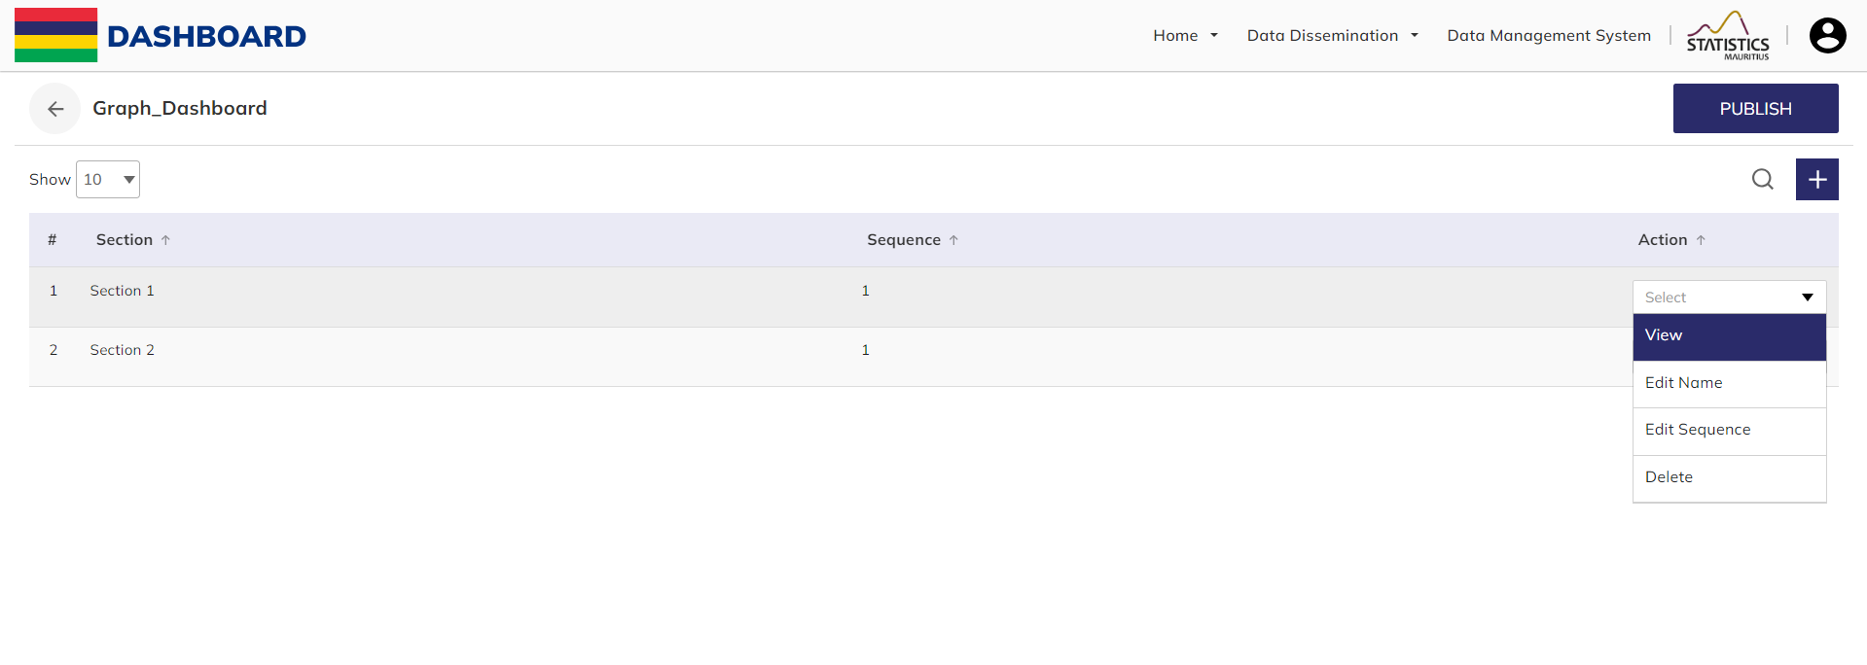**Step 4:** Click on the action dropdown menu of the section to **View** a section, **Edit** the name of the section, **Edit** the sequence of the section and **Delete** the section.

**Step 5:** There is option to add three visualization components to the dashboard which are available to the right side of the page.

* Gallery
* Elements
* Image

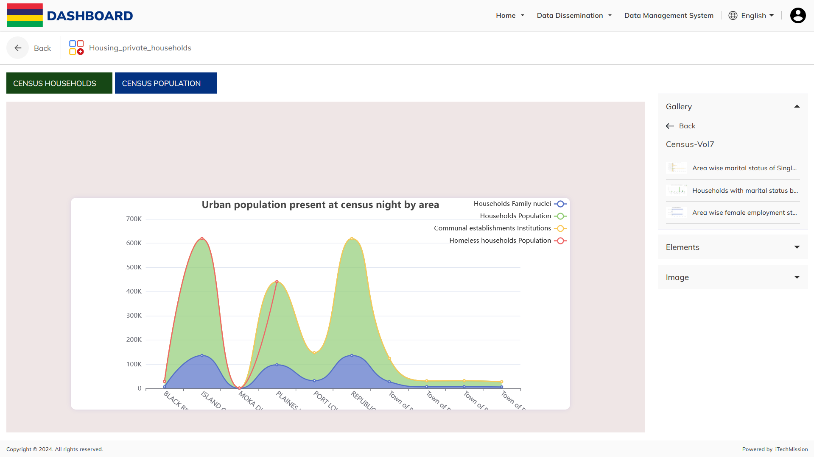**Step 6: Gallery** option provides you the list of saved visualizations that can be used to create dashboard. Click on the Gallery option to view the list of saved visualization. You can drag & drop the required chart to the empty dashboard and adjust its size & position as per the requirement.

**Step 7:** To fill the background color, click on the **Color picker** icon available at the top right corner of the visualization and select the required color.

**Step 8:** To remove the **Chart**, click on the Delete icon available at the top right corner of the **Chart** and the required chart will be removed from the dashboard.

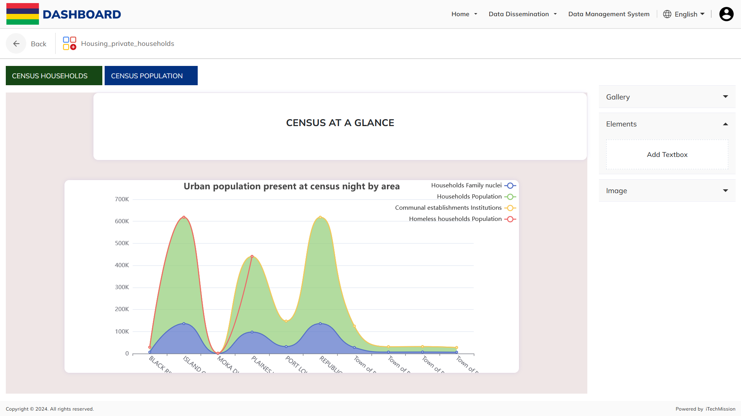**Step 9:** **Elements** option allows you to add customized textboxes to the dashboard. Click on the Elements option to drag & drop a textbox, a popup will appear for you to enter and save the information to be shown using the required textbox. You also have formatting options as per the requirement.

**Step 10: Image** option allows you to Select & Upload images to the list of Images. You can drag & drop the required image to the dashboard and adjust its size & position as per the requirement

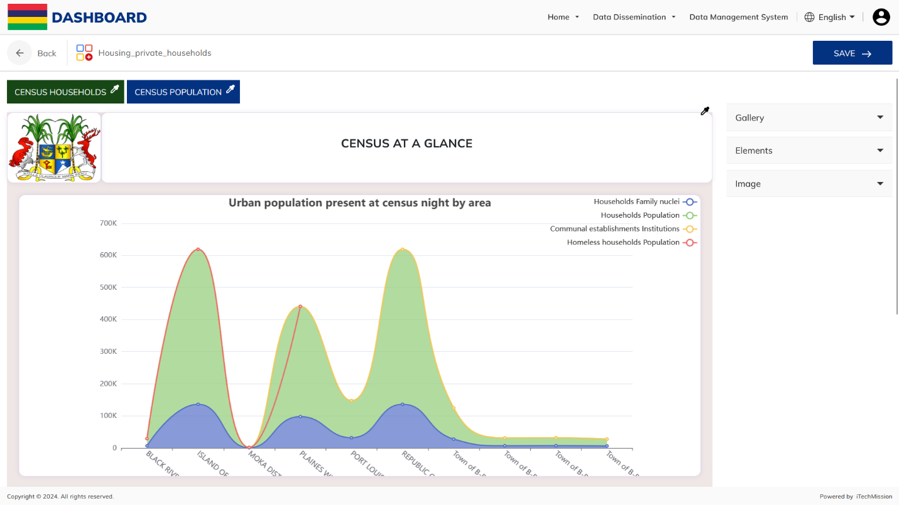**Step 11:** Click on **Save** to save the section.

**Step 12:** Click on **Publish** to publish the section.



PRODUCT DOCUMENT